Shrines, Sights & Shows of the Laurel Highlands
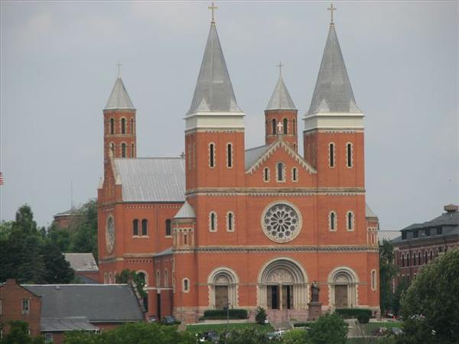
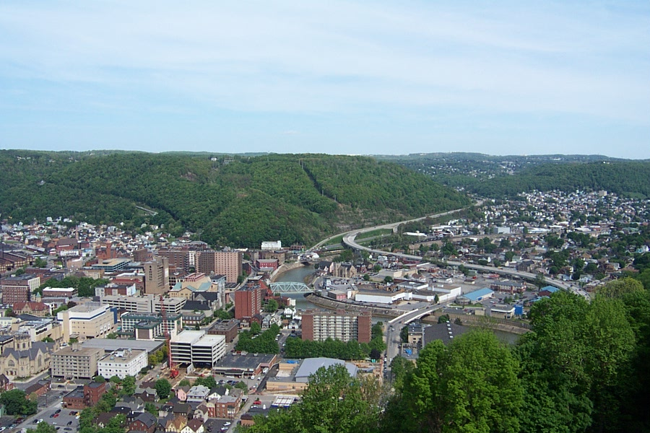

~featuring~
Saint Vincent Basilica ~ Johnstown Flood Museum ~ Flight 93 Memorial
Youghiogheny River Float Trip ~ Mountain Playhouse

Travel aboard a deluxe highway coach into the lovely Laurel Highlands of southwestern Pennsylvania. Design your own personalized group itinerary from the following venues. Visit Saint Vincent College & Seminary, home of the first Benedictine monastery and school in the United States. Enjoy a guided tour of the magnificent Saint Vincent Archabbey Basilica, built by Benedictine monks at the turn of the 20th century. Visit the Johnstown Flood Museum which features a 26-minute, 1989 Academy Award-winning documentary film along with several other multimedia exhibits depicting the cause of and the course of events prior to, during and after the devastating flood of May 31, 1889. Climb aboard the Inclined Plane for a scenic ride 502 feet up to an observation platform overlooking the city. Stop at Flight 93 Memorial which honors the 40 brave souls that gave their lives on September 11, 2001. Embark on a memorable historical float trip down the Youghiogheny River. Sit back and relax on large secure rubber rafts as experienced costumed guides take you back through time sharing the heritage and lore of the scenic Youghiogheny Valley. Schedule a delightful meal and show at the Mountain Playhouse. Recognized as Pennsylvania’s oldest professional resident summer theater, the Mountain Playhouse offers sparkling comedies and musicals in the historic gristmill.

Tour Cost: Call for updated pricing and availability.

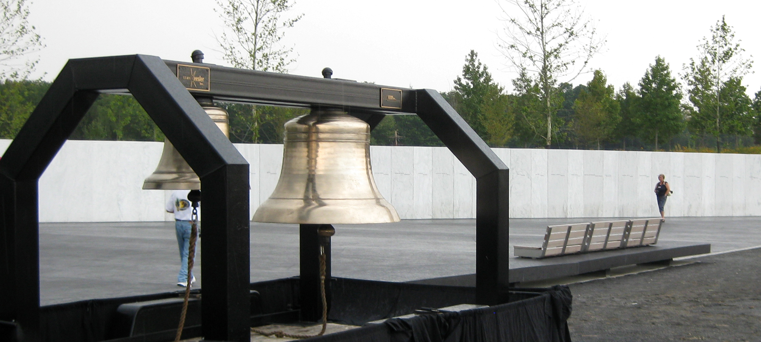
Travel Arrangements made by
Wendt Touring, Inc.
401 Market Street – Suite 707,
Steubenville, OH 43952
740-282-5790 or
toll-free 877-565-8687
www.WendtTouring.com

