Alaskan Adventure

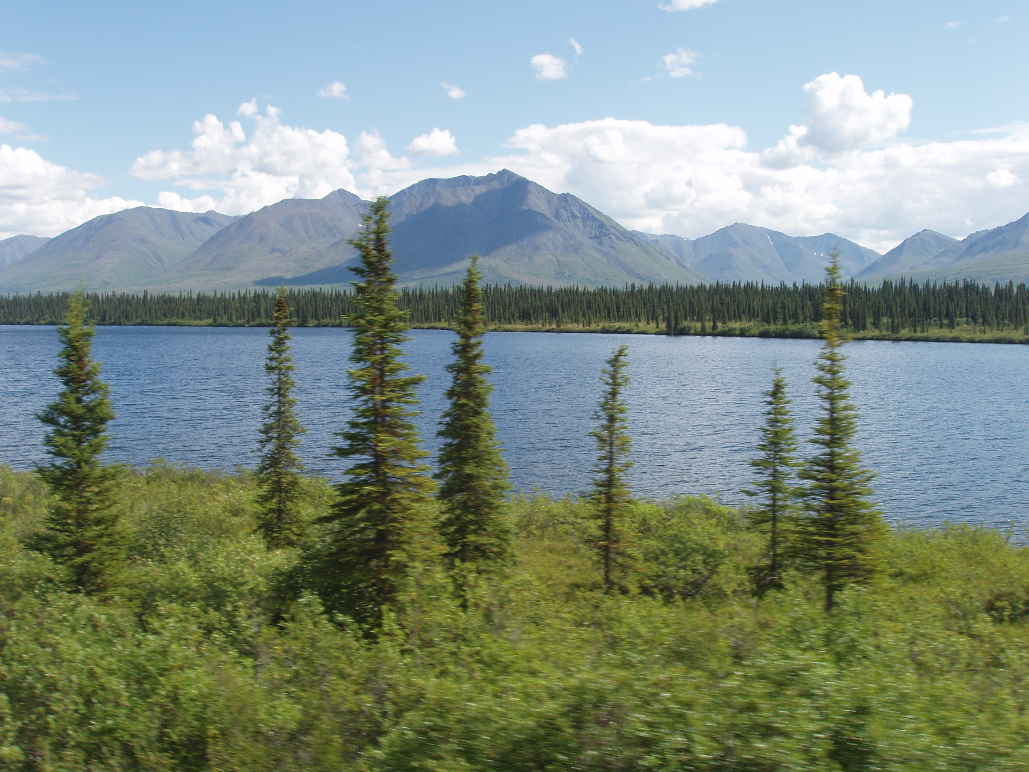

…with Holland America Line - Westours
& presented by Wendt Touring (11 days ~ 10 nights)

HIGHLIGHTS INCLUDE:
Fairbanks ~ McKinley Explorer Train ~ Denali National Park ~ Anchorage ~ Tundra Wilderness Tour ~ Tetlin Wildlife Refuge ~ Gold Dredge No. 8 Tour ~ Beaver Creek Glacier Bay National Park ~ Skagway ~ Whitehorse ~ Ketchikan ~ Alaska Highway Inside Passage Cruising Vancouver ~ Discovery Riverboat Cruise
Yukon Rendezvous Dinner Show ~ White Pass & Yukon Route Railroad

TOUR INCLUDES:
*Round trip scheduled air transportation
*Four night Alaska cruise aboard Holland America Line’s ms Statendam
*Six night's hotel accommodation with interior land tour
*Deluxe motorcoach and rail transportation throughout land tour
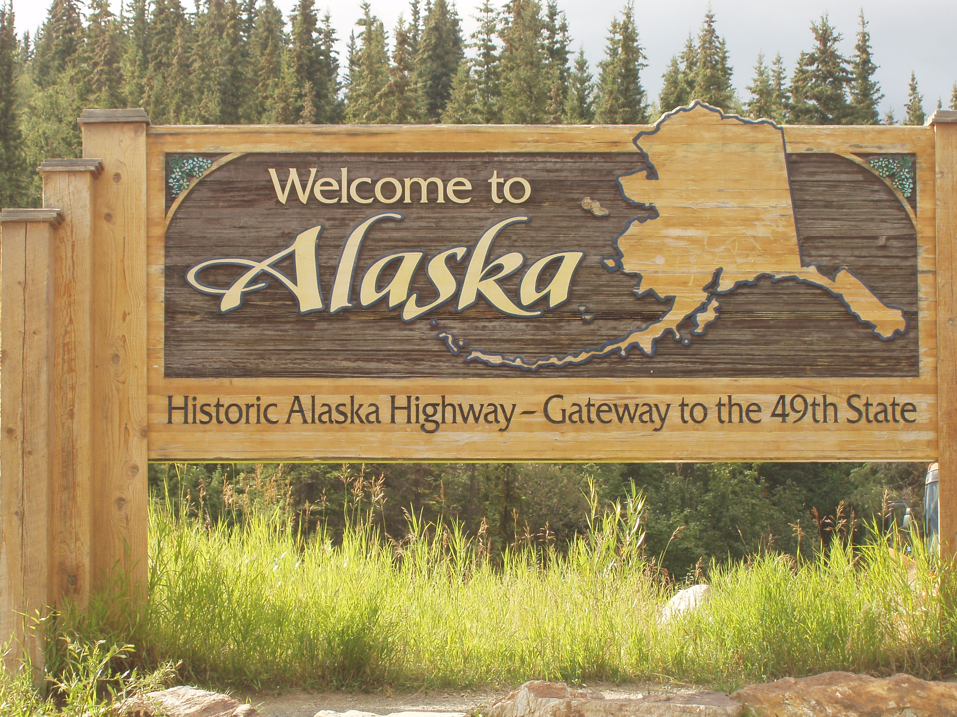
*All meals aboard cruise ship plus Yukon Dinner Show and Fairbanks lunch
*Port charges, airport departure taxes, baggage handling
*Professional Tour Manager in Alaska

TOUR FARE:
Please call for updated tour pricing and availability.

ITINERARY

Day 1: Home City – Anchorage: Fly to Anchorage aboard a scheduled airline and begin your tour exploring in Alaska’s largest city.
Day 2: McKinley Explorer to Denali National Park: Soak up dramatic scenery and enjoy expert narration as you travel aboard the largest domed railcars on the historic Alaska Railroad. Upon arrival at Denali National Park transfer to your resort-style lodge surrounded by glorious views.
Day 3: Denali Tour and McKinley Explorer to Fairbanks: Travel up to 53 miles of the Denali Park Road, enjoying great wildlife and Mt. McKinley viewpoints on your fully narrated Tundra Wilderness Tour. Later, reboard our award-winning luxury railcars to enjoy the spectacular sights that make the Alaska Railroad route a National Scenic Byway. Arrive in Fairbanks, Alaska’s fabled “Golden Heart” city, for an overnight stay downtown. Take in the frontier atmosphere on your choice of optional excursions.
Day 4: Fairbanks: Today we board the sternwheeler Discovery for a riverboat cruise which spotlights native culture, gold rush history and local color – a popular adventure! At Gold Dredge No. 8, a National Historic Site, you’ll enjoy our fascinating and exclusive tour. Browse mining exhibits and try your hand at gold panning (lunch included). Tonight explore under the Midnight Sun on a choice of optional excursions.
Day 5 Explorer Coach to Beaver Creek and Yukon Territory: Find yourself in the heart of true wilderness, passing the Tetlin Wildlife Refuge, the Wrangell Mountains, Delta Junction and more. After a pause at Rika’s Roadhouse, we’ll welcome you to Beaver Creek with our famed Yukon Rendezvous Dinner Show (included).
Day 6: Explorer Coach to Whitehorse: Enjoy wide-open vistas as the Alaska Highway weaves its way past the St. Elias Mountains and the sparkling waters of scenic Kluane Lake. Arriving in Whitehorse, the capital of the Yukon Territory, you can relax at your downtown hotel or explore.
Day 7: Whitehorse to Skagway, Embark on your cruise: Today’s travels take you through an amazing tapestry of ever-changing scenery to Fraser in the Yukon. Here you’ll board historic parlor cars. The White Pass & Yukon Route Railroad takes you through some of Alaska’s most breathtaking terrain. In Skagway (a living museum of the Gold Rush), board your luxurious ship, ms Statendam, and embark on a memorable cruise down the Inside Passage.
Day 8: Glacier Bay National Park Cruising: Today, the ms Statendam cruises through spectacular Glacier Bay National Park. How does it feel when a monumental chunk of ice splits off a glacier and crashes into the sea? The sound is like thunder. The impact shoots water hundreds of feet into the air. You hold your breath as you catch the moment on film. Then you wait for it all to happen again. And, it does. Glacier Bay has more actively calving glaciers than anywhere else in the world.
Day 9: Ketchikan: Ketchikan clings to the shores of Tongass Narrows and drapes the mountains with a cheerful air. Besides the main attractions – Creek Street, the Tongass Historical Museum, Totem Bright State Park, and Saxman Village – there is one other thing we highly recommend you do. A floatplane flightseeing trip to breathtaking Misty Fjords National Monument is a transforming adventure not to be missed.
Day 10: Inside Passage Cruising: The scenic waterway that reaches 1,000 miles from beautiful British Columbia to historic Skagway, Alaska. Through a maze of bays, straits, arms and fjords you’ll cruise past an ever-changing panorama of unspoiled beauty…cascading waterfalls, virgin forests, and majestic glacier-carved fjords.
Day 11: Disembark in Vancouver, British Columbia - Journey Home: This morning we disembark in Vancouver and begin our final journey home via scheduled airline.

Travel arrangements made by Wendt Touring, Inc.
401 Market Street, Suite 707, Steubenville, OH 43952
740-282-5790 or toll-free 1-877-565-8687
www.WendtTouring.com

