American Queen Mississippi Cruise

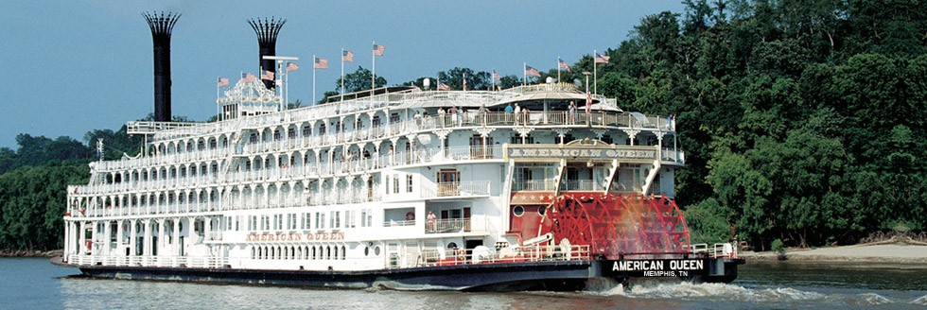

Presented by WENDT TOURING
~~~~~~~~~~~~~~~~~~~
9 days – 8 nights

PACKAGE INCUDES:

*Round-trip scheduled air to New Orleans returning from Memphis.
*One-night lodging in New Orleans at a first-class hotel with breakfast, taxes, and porterage.
*Seven-night Mississippi River cruise aboard the American Queen with stops at Oak Alley,
St. Francisville, Natchez, Vicksburg, Helena & Memphis.
*American Queen features:

Complimentary Hop-On, Hop-Off shore excursions in every port
Complimentary wine and beer with dinner
Complimentary cappuccino, espresso, specialty coffees, bottled water and soft drinks
The only steamboat with multiple specialty dining options, all at no additional charge
Gracious service from a friendly all-American staff
Casual elegance abounds, no formal wear required
Daily lectures by the Riverlorian, our onboard historian
Professional showboat-style entertainment and dancing nightly
The only authentic steam-powered overnight paddlewheel riverboat in America

*All port charges, airport transfers in New Orleans and Memphis & taxes.
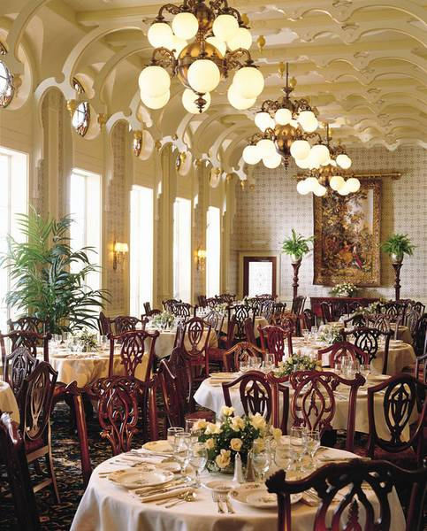
PRICES:

*Please call for updated cruise pricing

Travel arrangements made by Wendt Touring, Inc.
401 Market Street – Suite 707, Steubenville, OH 43952
740-282-5790 or toll-free 1-877-565-8687

www.WendtTouring.com

ITINERARY

Day 1: Home City to New Orleans, LA
Fly scheduled air to New Orleans. Upon arrival transfer to downtown hotel which provides an opportunity to explore this exciting city. Overnight in New Orleans.

Day 2: New Orleans, LA
Following breakfast at the hotel enjoy the sights and sounds of New Orleans today. This afternoon, you will board the American Queen to begin your voyage. Kick off the festivities with a Welcome Aboard Dinner. Departure: 9:00 p.m.

Day 3: Oak Alley, LA
Arrival: 8:00 a.m. — Departure: 1:00 p.m.
Located in the Saint James Parish, Oak Alley is a much-photographed plantation that combines architectural splendor and the natural wonder of its 300-year-old oak trees. Spend time strolling beneath the canopy of these trees, and learn about the rich history and culture of this southern estate.

Day 4: St. Francisville, LA
Arrival: 8:00 a.m. — Departure: 1:00 p.m.
This quaint town located on the bluffs of the Mississippi River is your window to the past. With over 140 buildings on the National Register, beautiful plantation homes nestled in the rolling countryside, and bustling Main Street shops, you’ll find plenty to keep you on the go in St. Francisville.

Day 5: Natchez, MS
Arrival: 8:00 a.m. — Departure: 5:00 p.m.
Step into the plantation lifestyle of the antebellum south in Natchez, site of numerous restored mansions. Visit historic Jefferson College, or just amble down the Natchez Trace.

Day 6: Vicksburg, MS
Arrival: 8:00 a.m. — Departure: 1:00 p.m.
Discover a unique blend of old and new in Vicksburg, Mississippi. Take in the diversity from Vicksburg National Military Park to the Waterways Experiment Station. Billed as the “Red Carpet City of the South,” Southern hospitality is alive and well and awaiting your arrival.

Day 7: Steamboating
Settle into a rocking chair and just let the scenery glide by. Or join in the fun of our numerous onboard activities. Your full day of leisurely steamboating on the river sets the tone for an unforgettable vacation.

Day 8: Helena, AR
Arrival: 8:00 a.m. — Departure: 1:00 p.m.
Let gospel voices lift your heart, hear soulful Delta blues, and sample King biscuits and sausage during an eventful day.

Day 9: Disembark in Memphis, TN
Arrival: 8:00 a.m. - Disembark in Memphis and transfer to the airport for our flight home.

