Shrines & Sights
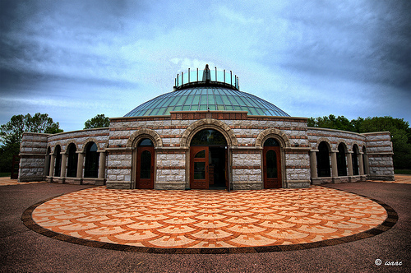
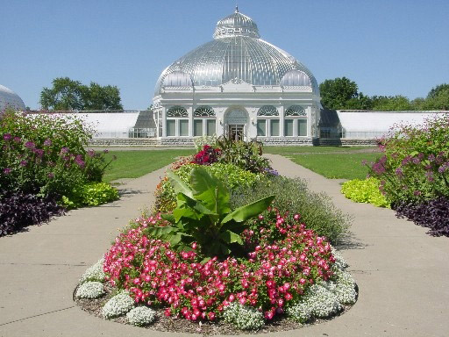
of
Niagara Falls

***********

Presented by WENDT TOURING…..2 days ~ 1 night

HIGHLIGHTS INCLUDE:
National Shrine Basilica of Our Lady of Victory ~ Arrowhead Winery
Niagara Falls, NY ~ National Shrine Basilica of Our Lady of Fatima
Salvatore’s ~ Woyshner’s Christmas Shop ~ Buffalo Botanical Gardens

TOUR INCLUDES:
- Deluxe motorcoach transportation
- One night lodging
- Dinner at Salvatore’s Italian Gardens Restaurant
- Breakfast at hotel
- All sightseeing & admissions
- Daily Mass & Prayer
- Professional Tour Manager

TOUR FARE:
Please call for current tour pricing and availability.

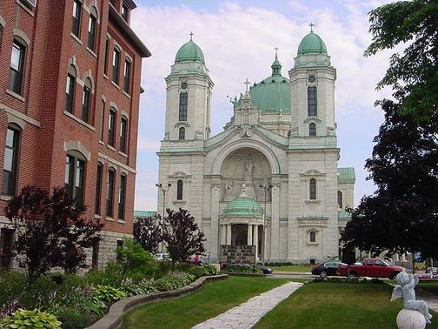
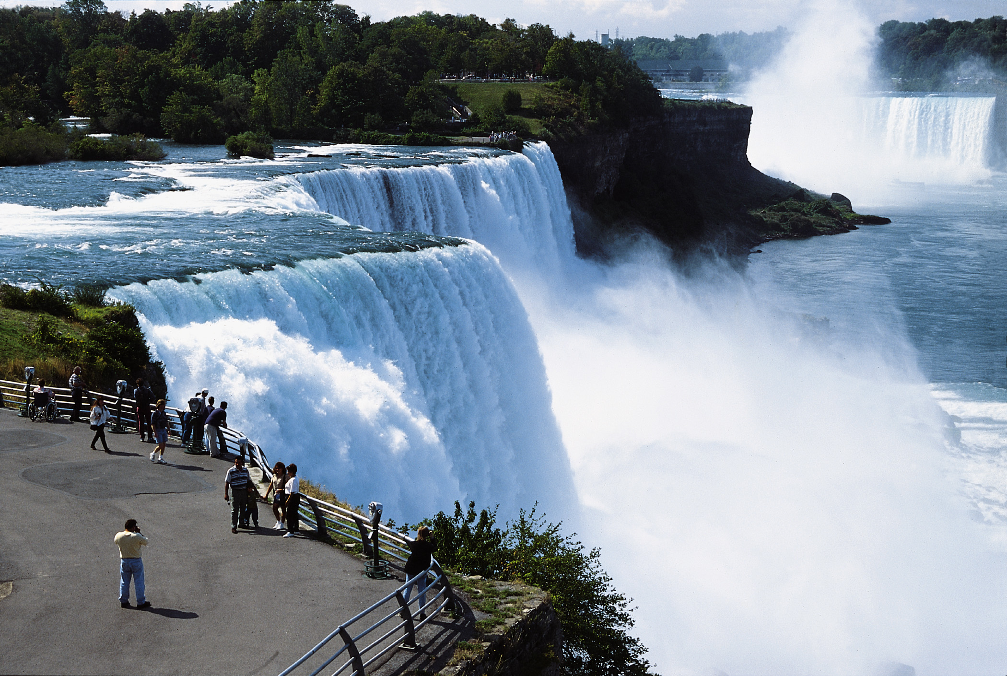

ITINERARY

Day 1: Home City ~ Basilica of the National Shrine of Our Lady of Victory ~ Woyshner’s Christmas Shop/Buffalo Botanical Gardens ~ Salvatore’s Italian Gardens: Travel aboard a deluxe highway touring motorcoach to New York State. As we travel rest and meal stops will be made periodically. Later this morning arrive in Lackawanna and to the magnificent Basilica of the National Shrine of Our Lady of Victory. Constructed in 1921 as our nation’s second oldest Basilica, Our Lady of Victory Church is built in elegant fourteenth and fifteenth-century Italian Renaissance style. The Basilica stands as a reflection of the life and work of Father Henry Baker who, through the intercession of Mary, saved thousands of orphaned and troubled boys and provided aid to multitudes of adults in hard economic times. We will enjoy a guided tour of the Basilica and then celebrate Mass. Time will also be provided for personal prayer, gift shop and museum on Father Baker. Later this afternoon enjoy a stop at either Woyshner’s Christmas Shop or Buffalo Botanical Gardens. Woyshner’s Christmas Shop features a wonderful selection of Christmas items. The Buffalo Botanical Gardens houses tropical and subtropical plants in a restored, triple-domed glass conservatory patterned after England’s Crystal Palace. Later today we arrive at the lovely Garden Place Hotel for check-in and time to refresh before a special evening. Dinner tonight is at Salvatore’s, one of the most acclaimed restaurants in western New York. Step into another world, where crystal chandeliers, etched glass, classic sculptures, Remington bronzes and marble define elegant, elaborate, Italian-style architecture.

Day 2: Niagara Falls State Park, NY ~ National Shrine Basilica of Our Lady of Fatima ~ Arrowhead Winery: Following breakfast at the hotel depart for Niagara Falls State Park, New York’s oldest state park. Enjoy free time to explore the park which provides several observation areas overlooking the falls as well as numerous attractions, gift shops and restaurants. Niagara Falls has never ceased to be a natural wonder, mesmerizing travelers from around the world. Later today we arrive at the National Shrine Basilica of Our Lady of Fatima. Since 1954, Our Lady of Fatima Shrine has become a place of natural beauty, art, prayer and renewal to thousands who visit the shrine each year. The magnificence and natural beauty of the Shrine is highlighted by an awe-inspiring chapel whose semi-transparent dome depicts the Northern Hemisphere. Celebrate Mass in the chapel and then enjoy free time to walk the lovely grounds or visit the gift store. Later this afternoon we depart western New York and begin our journey home. En route home we will stop at Arrowhead Winery in the Lake Erie Region and enjoy a guided tour followed by the opportunity to sample various wines.

Travel Arrangements made by Wendt Touring, Inc.
401 Market Street – Suite 707, Steubenville, Ohio 43952
740-282-5790 or Toll-free 877-565-8687
www.WendtTouring.com

